NEWSLETTER
Issue No. 7. May 2017

Introduction:
Spring is here and warm weather is at last with us. If you went to see our last production, Office Hours at the Pumphouse Theatre you probably had a sense of spring. Not because of the excellent play, but to get to the theatre you needed to trudge through the slush and mud and jump over the pools of water outside of the Theatre. But the exercise was worthwhile because the play was certainly worth the effort. It was a great show!
Since the last Newsletter, we have been active: in addition to Office Hours, we had a successful lunchtime performance in support of elder abuse at the John Dutton Theatre in downtown Calgary.
We now have a webpage where you can visit us (www. confederationtheatre.ca) and we have achieved charitable status. You will soon be able to donate money to Confederation Theatre Society and receive a tax receipt. All money received will go toward mounting our future productions.
As usual in this issue, we hope that we can entertain you and make you laugh with some jokes and memorable quotes.
````````````````````````````````````````````````````````````````
“Office Hours”
From March 10th to March 18th we presented, at the Pumphouse, Norm Foster’s very funny play “Office Hours”. The audience was treated to some fine performances from the actors in a well- constructed play. The set was magnificent, and the lighting and sound were perfect. Another fine performance from our Confederation Theatre. (See some photographs below)
A quote from the audience: “The best play that I have seen at the Pumphouse so far.” JB.

Photographs from “Office Hours”
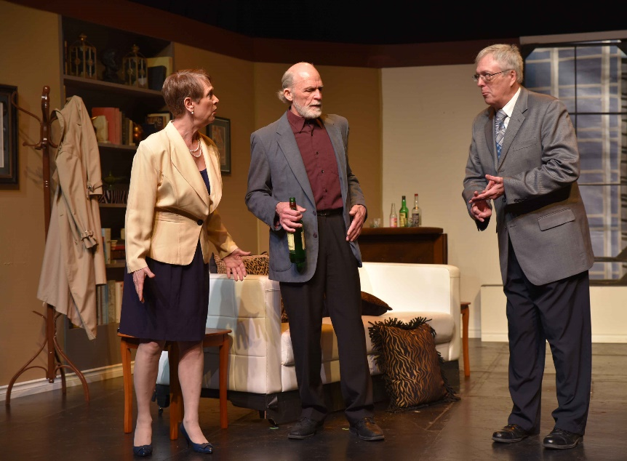
Michelle Yoder, Gordo Blakhart and Bill McCarthy
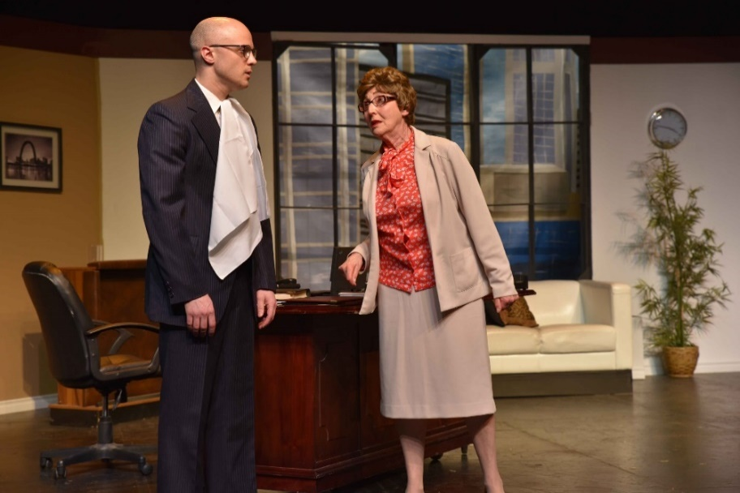
Jamie Cunnington and Zena Drabinsky
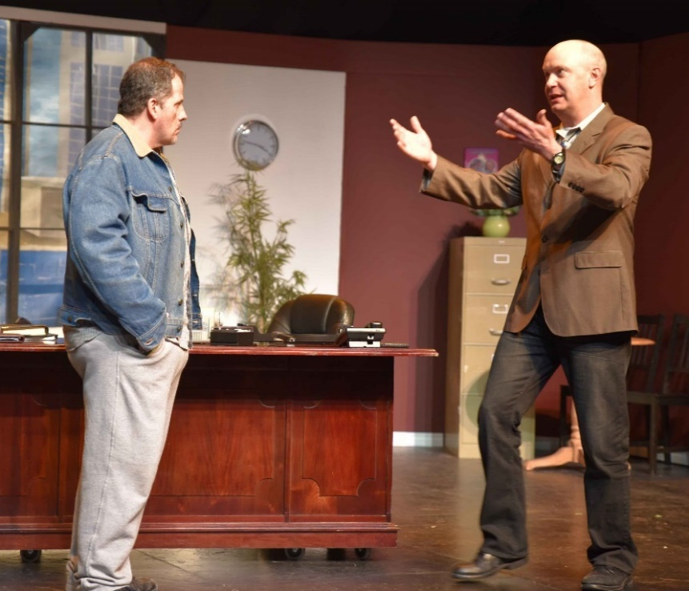
Ross Hart and Tony Norman

Kevin Chinook, Colleen Bishop and Ross Hart

Our next production:
“Deadly Illusions”
by Alan LeBoeuf

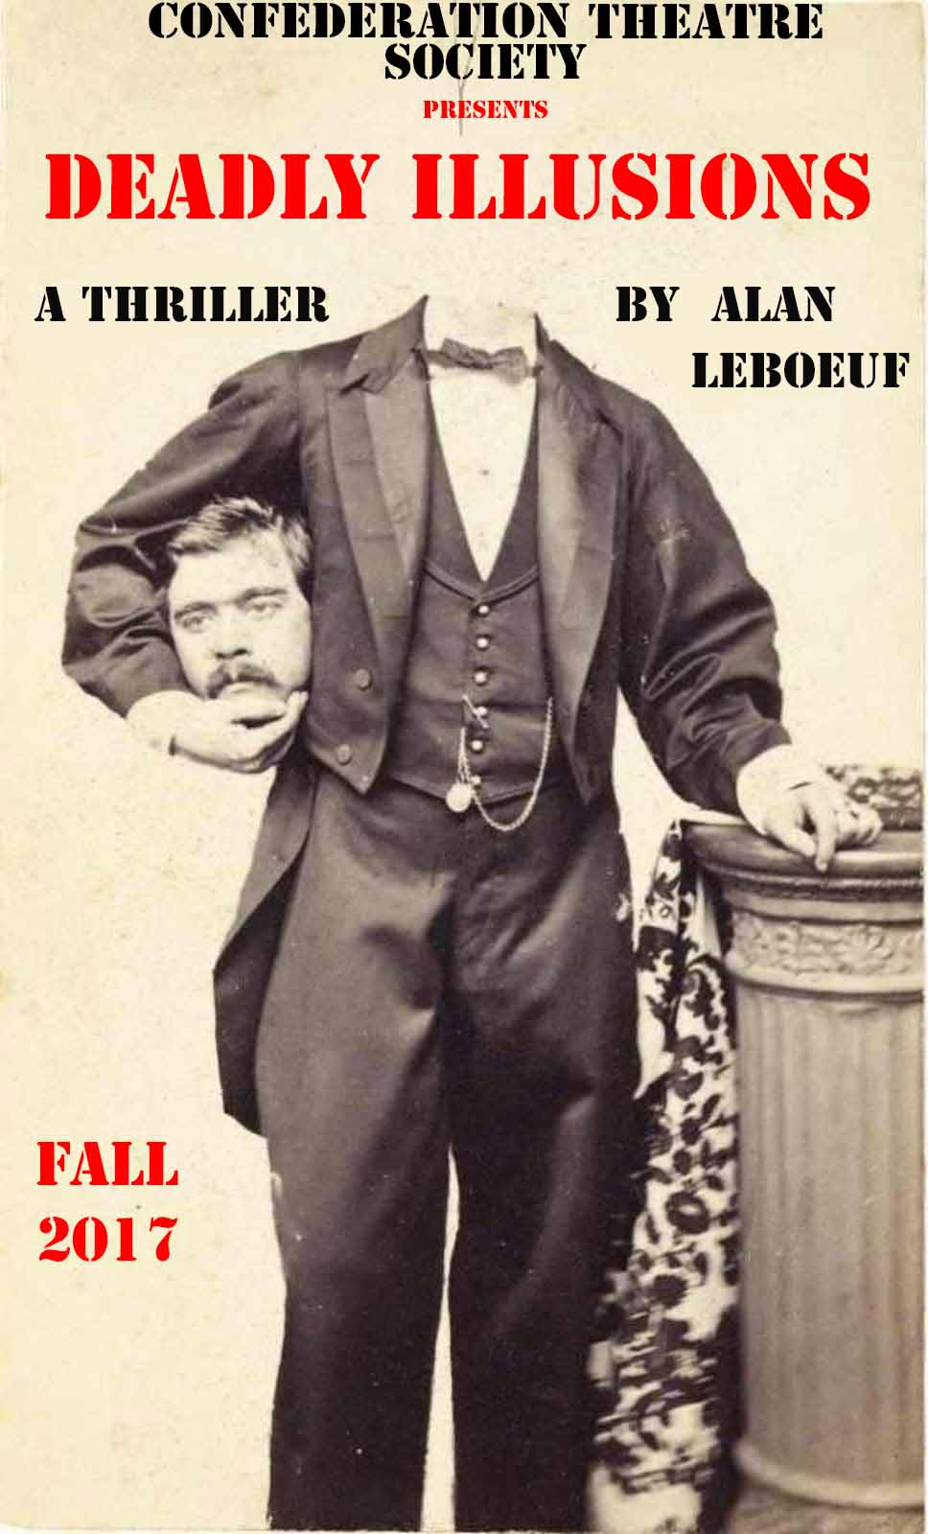

Friday, October 20th 2017 to Saturday, October 28th 2017, we will present at the Pumphouse Theatre, the World Premiere of playwright Alan LeBoeuf’s thriller, “Deadly Illusions”.
Illusions are sometimes a case of now you see it and now you don’t. But when the Great Boudin premieres his latest grand illusion, you certainly see something. Unfortunately for poor Boudin, it’s not quite what was expected. Life can be dangerous for illusionists. Just ask Harry Houdini. You see, there’s nothing magical about dead bodies and there's nothing magical about Inspector Sorochan. He’s a plodder but he always seems to get his man. But could this be his last case? Could there be another murder or will this just be another illusion that goes?
This play, directed by Louis B. Hobson, will be co-sponsored by the Kinsmen Club of Calgary and is in aid of a local charity.

Performance dates are as follows:
- Friday, October 20th , 2017
- Saturday, October 21st, 2017
- Tuesday, October 24th, 2017
- Wednesday, October 25th, 2017
- Thursday, October 26th, 2017
- Friday, October 27th, 2107
- Saturday, October 28th, 2017
We plan a matinée on the final Saturday. Evening shows start at 7:30 p.m. and the Saturday matinée starts at 2:30 p.m. We look forward to seeing you at one of our performances.

For tickets:
email – ctstickets@yahoo.ca
Phone – (587) 577-3669

.
````````````````````````````````````````````````````````````````
True or not so true Vignettes of “The Golden Years”
On February 24th 2017, we performed six skits at the John Dutton Theatre at the Central Library in support of carya and their work to make the public aware of elder abuse. After the performance there was a question and answer period followed by refreshments provided by “Meals on Wheels”.
Some comments on the performance:
“I wanted to thank you and Confederation Theatre group again for such an amazing performance.
All of the feedback I received was very positive and the older adults in the crowd were really wanting more!”
-Alison Jozsa of carya.

“You and your cast did all the hard work and it was obvious that the audience really enjoyed it. Thanks to all
of you for a brilliant performance. It was my privilege to be part of the day.” - Cari Gulbrandsen of carya.
As a result of the production at the John Dutton Theatre, we have been asked by carya to perform the “Social Workers” skit again at the John Dutton Theatre on Thursday June 15th 2017 as a part of World Elder Abuse Awareness Day. There will be Elder Abuse Awareness activities and a Rally. Carya will invite the Mayor to offer a proclamation about Elder Abuse at the meeting.
In addition, on June 6th 2017, we are scheduled to repeat our performance in High River for Alberta Health Services as a part of their Seniors Week.
If your group is interested in hosting a performance, please contact us. You can contact Paul Brown at paul_brown@shaw.ca.

Photographs from February 24th 2017 ‘ Vignettes’ performance
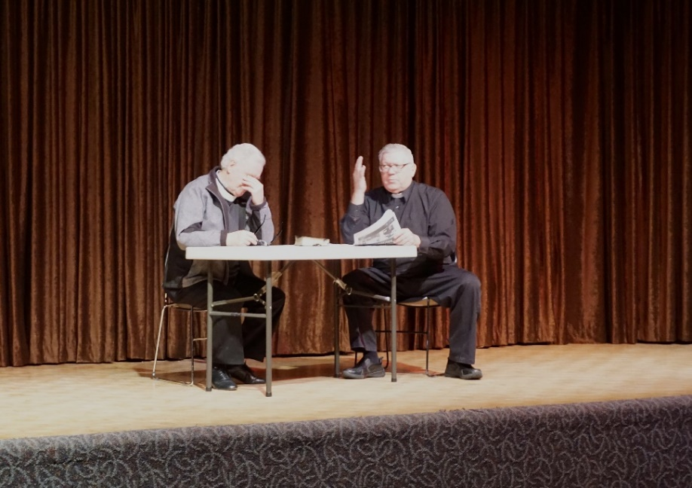
Terry Whittaker and Bill Ouellet in “The Vicar”
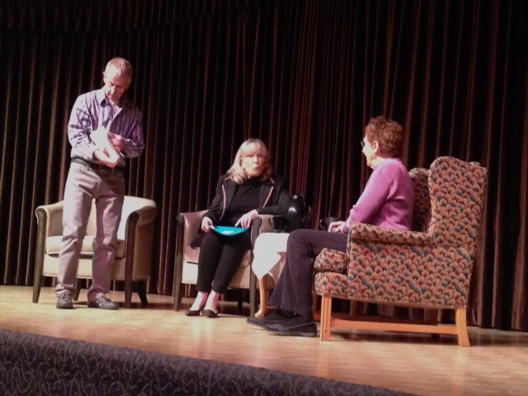
Peter Whitehead, Terry Ager and Zena Drabinsky in “The Social Worker”
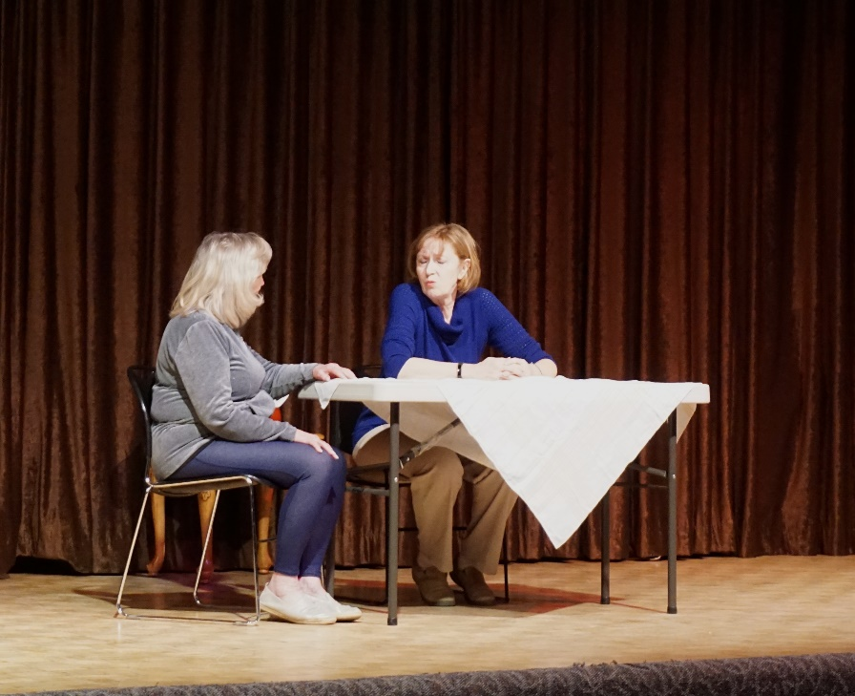
Terry Ager and Kathy Shore in “Paddy”
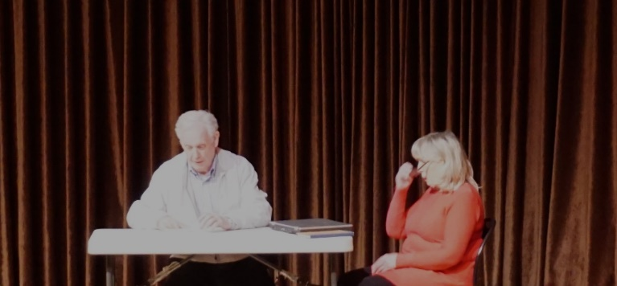
Terry Whittaker and Terry Ager in “E.S.L”
````````````````````````````````````````````````````````````````
CONFUSING SIGNS: (Did I read that right?)
In a department store: Bargain basement upstairs.
Notice in a health food shop window: Closed due to illness.
Spotted in a safari park: Elephants please stay in your car
On a repair shop door: We can repair anything. (Please knock hard – the bell doesn’t work)
Police begin campaign to run down jaywalkers: (that’s taking things a bit too far)

...and a couple more signs...
Red tape holds up new bridges: (is red tape stronger than duct tape?)
Cold wave linked to temperatures: (Now there’s a surprise)
````````````````````````````````````````````````````````````````
Future Production:
“SHACKLETON”
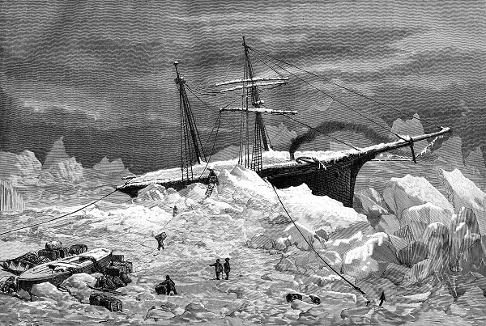

In February/March 2018 we will present the true story of “Shackleton”. This is a radio play about the Antarctic Explorer, Sir Ernest Shackleton. This true story is of one of the great heroic adventures of the 20th century. In 1914, Shackleton set out from London on his way to the frozen Antarctic. The plan was to trek across the continent, a journey of 1,800 miles and cross the actual South Pole. Unfortunately, the ship became stuck in the ice and sank.

The crew were forced to abandon ship and with the expedition now over, started a long on-ice journey for survival. They had no contact with the rest of the world and the world did not know where they were. They were far from the normal shipping routes with zero chance of rescue. They were alone in a frozen wasteland.
This captivating story will be recreated with sound effects in our 2018 radio play production. Don’t miss it!

Web page.
You can now visit us at our web page – www.confederationtheatre.ca
````````````````````````````````````````````````````````````````
Charitable Status.
Confederation Theatre Society has now achieved charitable status. You will soon be able to donate money to us and receive a tax receipt. All money received goes directly into our upcoming productions. Thank you for your support!

````````````````````````````````````````````````````````````````
Congratulations to the lucky raffle winners from our Office Hours raffle:
1. The helicopter ride Ticket No. 120. Name: Jennifer Harris
2. Stage West Ticket No. 274. Name: Steve Clayden
3. Spolumbos Ticket No. 077. Name: Tracy Carlson
````````````````````````````````````````````````````````````````
A Little Night Reading
We are resuming our “A Little Night Reading” activities, where we workshop new Canadian plays. The first is “The Lady Olivier Papers” a play by Ingrid Hansen-Smythe and the second “Aint She Sweet” by Judy Paul and Terry Whittaker. Notification of play names, playwrights and dates of the readings will be sent through the Calgary ACTS emails. The readings will take place at the Dog and Duck pub – 5340 2nd Street SW. Calgary, starting at 7 p.m.

```````````````````````````````````````````````````````````````
And finally a few more interesting quotes:

- There's nowhere to hide in the theatre. You can't be the one in rehearsal who doesn't know their lines. - Keely Hawes
- The miracle is not that we do this work, but that we are happy to do it. – Mother Teresa
- Life was a funny thing that happened to me on the way to the grave. - Quentin Crisp

- Loneliness and the feeling of being unwanted is the most terrible poverty. - Mother Teresa
- The hardest thing to understand in the world is the income tax. - Albert Einstein
- It is true that liberty is precious; so precious that it must be carefully rationed. - Vladimir Lenin

